

***System Provisioning and Configuration Management***

***Submitted by:***

***NAME: Tanishqua Tellakula***

***SAP ID: 500084269***

***Roll number: R120220007***

***Batch: B1(Hons)***

***EXPERIMENT 5***

***Provisioning an S3 Bucket on AWS***

***Exercise Steps:***

***Step 1: Create a New Directory:***

*Create a new directory to store your Terraform configuration:*

***mkdir Terraform-S3-Demo***

***cd Terraform-S3-Demo***

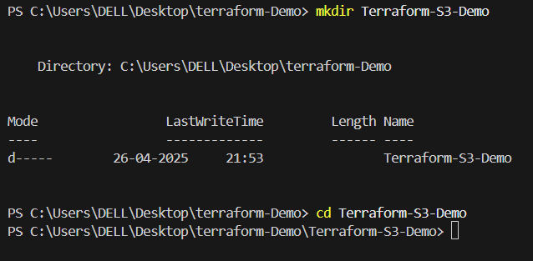

***Step 2: Create the Terraform Configuration File (main.tf):***

*Create a file named main.tf with the following content:*

***terraform {***

***required_providers {***

***aws = {***

***source = "hashicorp/aws"***

***version = "5.31.0"***

***}***

***}***

***}***

***provider "aws" {***

***region = "us-east-1" # Replace with your preferred region***

***access_key = "your IAM access key" # Replace with your Access Key***

***secret_key = "your secret access key" # Replace with your Secret Key***

***}***

*This file sets up the Terraform AWS provider.*

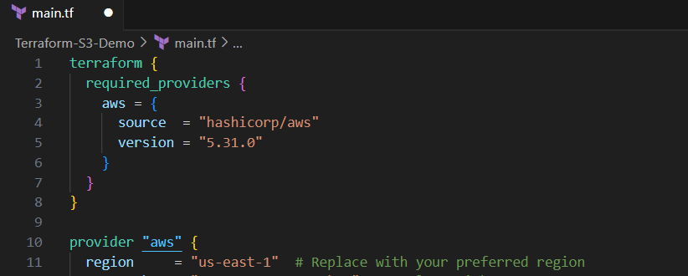

***Step 3: Create a Terraform Configuration File for the S3 Bucket (s3.tf):***

*Create another file named s3.tf with the following content:*

*resource "aws_s3_bucket" "my_bucket" {*

*bucket = "my-demo-s3-bucket"*

*tags = {*

*Name = "Terraform-S3-Bucket"*

*}*

*}*

*This file provisions an S3 bucket with a unique name using a random string suffix.*

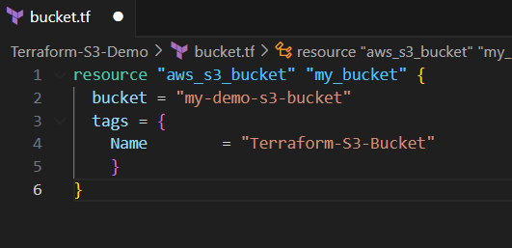

***Step 4: Initialize Terraform:***

*Run the following command to initialize your Terraform working directory:*

*terraform init*

***Step 5: Review the Plan:***

*Preview the changes Terraform will make:*

*terraform plan*

*Review the output to ensure it meets your expectations.*

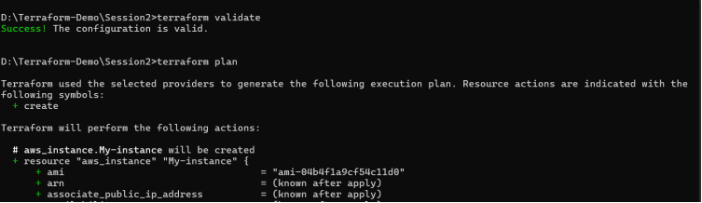

***Step 6: Apply the Changes:***

*Create the resources:*

*terraform apply*

*When prompted, type yes to confirm.*

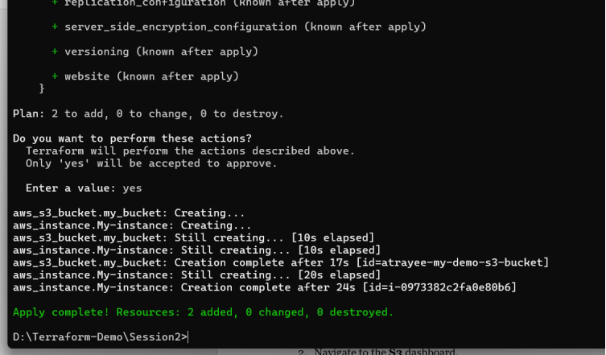

***Step 7: Verify Resources:***

*1. Log in to your AWS Management Console.*

*2. Navigate to the* ***S3*** *dashboard.*

*3. Verify that the S3 bucket has been created with the specified configuration.*

***Step 8: Cleanup Resources:***

*To remove the resources created, run the following command:*

*terraform destroy*

*When prompted, type yes to confirm.*

